Supplementary material
The tables and figures below give the model inputs, sensitivity analyses, supporting result matrices, scale calculations and data maps on which the main text draws.
Table S1. AR6 Table 7.15 emission metrics used throughout. Biogenic methane is weighted at 27.0 at GWP-100, not at a value adjusted for the molar mass of carbon.
gas | gwp20 | gwp100 | gtp100
CH4_fossil | 82.5 | 29.8 | 7.5
CH4_nonfossil | 79.7 | 27.0 | 4.7
N2O | 273.0 | 273.0 | 233.0

Table S2. Model input: rewetted organic soils, t CO2e/ha/yr, positive = source. CO2 only is the countable soil carbon term; the net column adds DOC and methane. These are absolute fluxes, not benefits.
Zone | Nutrient status | n | CO2 only | Absolute net GWP-100
Boreal | Poor | 26 | -1.25 | 0.52
Boreal | Rich | 39 | -2.02 | 3.21
Temperate | Poor | 43 | -0.84 | 3.35
Temperate | Rich | 15 | 1.83 | 10.49
Tropical | All | 11 | 0.00 | 3.35
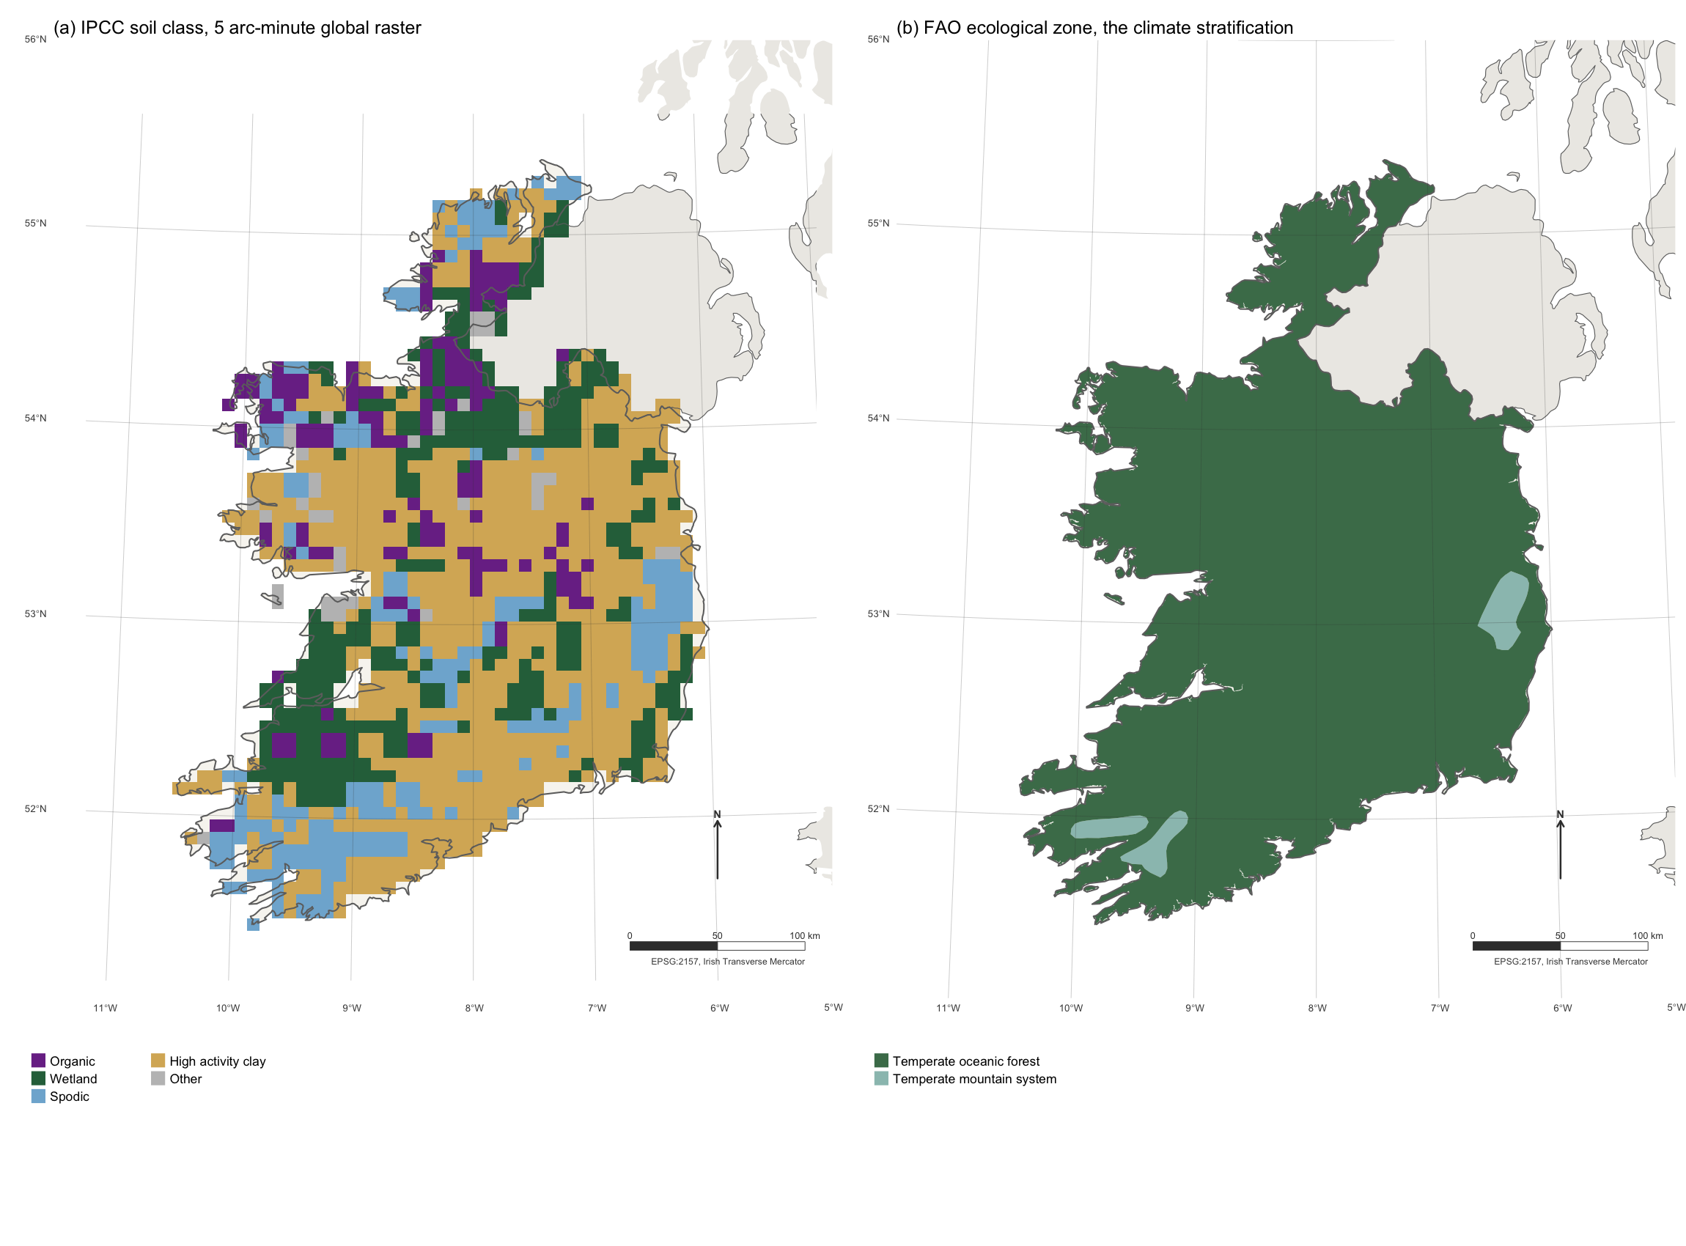
Figure S1. The two global layers that select which Tier 1 default applies, clipped to the Republic of Ireland. (a) The 5 arc-minute IPCC soil classification derived from the Harmonised World Soil Database. (b) FAO Global Ecological Zones 2010, the climate stratification. Graticule at one degree, EPSG:2157 Irish Transverse Mercator, north arrow and bar scale in the lower right of each panel.
Table S3. Effect of treating the published central value as the mode of a triangular distribution on right-skewed bounds, rewetted organic soils, kg CH4-C/ha/yr.
Zone | Nutrient | Published CH4 | Sampled mean | Ratio
Boreal | Poor | 41 | 96.4 | 2.34
Boreal | Rich | 137 | 210.1 | 1.53
Temperate | Poor | 92 | 182.0 | 1.96
Temperate | Rich | 216 | 357.9 | 1.66
Tropical | All | 41 | 61.1 | 1.48

Table S4. Sensitivity of the headline count to the distributional assumption, out of thirteen rows, on identical published bounds.
Sampling distribution | Rows below P 0.95
Triangular (mode at published value) | 5
Normal (mean at published value) | 5
Uniform on the published bounds | 6

Table S5. Coastal wetland soil carbon, t CO2/ha/yr removed. Headroom depends on the stock present at rewetting; the bare-start column is an upper bound, not an expectation. Table 4.11 is titled for extraction activities and its column is the stock destroyed by excavation, not a documented accumulation ceiling. Salinity columns are NA for seagrass because Table 4.14 covers tidal marsh and mangrove only.
System | n | Soil gain | Headroom | at 25% stock | at 50% stock | Net >18 ppt | Net <18 ppt
Mangrove | 69 | 5.94 | 238 | 179 | 119 | 5.94 | 0.71
Tidal marsh | 66 | 3.34 | 280 | 210 | 140 | 3.34 | -1.89
Seagrass | 6 | 1.58 | NA | NA | NA | NA | NA

Table S6. Coastal wetlands with and without the counterfactual, t CO2e/ha/yr. The absolute columns are the restored state alone, positive = removal. The benefit columns subtract the restored state from the Table 4.13 drained counterfactual of 28.97 t CO2/ha/yr and are the quantity the hypothesis concerns.
System | Absolute >18 ppt | Absolute <18 ppt | Benefit >18 ppt | Benefit <18 ppt
Mangrove | 5.94 | 0.71 | 34.91 | 29.68
Tidal marsh | 3.34 | -1.89 | 32.31 | 27.08

Table S7. Inland wetland mineral soils, rewetting, t CO2e/ha/yr at GWP-100. Positive is a removal; the methane column is an emission and is subtracted. Table 5.3 sets two consecutive 20-year blocks, so the annual gain is not constant. Methane is the zone-matched Table 5.4 factor.
Zone | SOCref | Gain yr 1-20 | Gain yr 21-40 | CH4 offset | Net yr 1-20 | Net yr 21-40
Boreal | 116 | 1.91 | 4.25 | 2.05 | -0.14 | 2.20
Cold temp dry | 87 | 1.44 | 3.19 | 6.34 | -4.90 | -3.15
Cold temp moist | 128 | 2.11 | 4.69 | 6.34 | -4.23 | -1.65
Warm temp dry | 74 | 1.22 | 2.71 | 6.34 | -5.12 | -3.63
Warm temp moist | 135 | 2.23 | 4.95 | 6.34 | -4.11 | -1.39
Tropical dry | 22 | 0.36 | 0.81 | 24.30 | -23.94 | -23.49
Tropical moist | 68 | 1.12 | 2.49 | 24.30 | -23.18 | -21.81
Tropical wet | 49 | 0.81 | 1.80 | 24.30 | -23.49 | -22.50
Tropical montane | 82 | 1.35 | 3.01 | 24.30 | -22.95 | -21.29

Table S8. Improved grassland with high input. Gains in t CO2/ha/yr removed, accruing over 20 years and zero thereafter.
Climate zone | Soil | SOCref (t C/ha) | F after | Gain from nominal | Gain from degraded
Cool temp moist | HAC | 81 | 1.265 | 3.94 | 8.40
Cool temp moist | LAC | 76 | 1.265 | 3.70 | 7.88
Cool temp moist | VOL | 136 | 1.265 | 6.62 | 14.10
Cool temp moist | WET | 128 | 1.265 | 6.23 | 13.27
Cool temp dry | HAC | 43 | 1.265 | 2.09 | 4.46
Cool temp dry | LAC | 33 | 1.265 | 1.61 | 3.42
Cool temp dry | VOL | 20 | 1.265 | 0.97 | 2.07
Cool temp dry | WET | 87 | 1.265 | 4.23 | 9.02
Tropical montane | HAC | 51 | 1.288 | 2.69 | 5.49
Tropical montane | LAC | 44 | 1.288 | 2.32 | 4.74
Tropical montane | VOL | 96 | 1.288 | 5.06 | 10.34
Tropical montane | WET | 82 | 1.288 | 4.32 | 8.83
Tropical wet | HAC | 60 | 1.299 | 3.29 | 6.59
Tropical wet | LAC | 52 | 1.299 | 2.85 | 5.71
Tropical wet | VOL | 77 | 1.299 | 4.22 | 8.45
Tropical wet | WET | 49 | 1.299 | 2.68 | 5.38
Tropical moist | HAC | 40 | 1.299 | 2.19 | 4.39
Tropical moist | LAC | 38 | 1.299 | 2.08 | 4.17
Tropical moist | VOL | 70 | 1.299 | 3.83 | 7.68
Tropical moist | WET | 68 | 1.299 | 3.72 | 7.46
Tropical dry | HAC | 21 | 1.299 | 1.15 | 2.30
Tropical dry | LAC | 19 | 1.299 | 1.04 | 2.09
Tropical dry | VOL | 50 | 1.299 | 2.74 | 5.49
Tropical dry | WET | 22 | 1.299 | 1.20 | 2.41
Warm temp moist | HAC | 64 | 1.265 | 3.11 | 6.63
Warm temp moist | LAC | 55 | 1.265 | 2.68 | 5.70
Warm temp moist | VOL | 138 | 1.265 | 6.71 | 14.30
Warm temp moist | WET | 135 | 1.265 | 6.57 | 13.99
Warm temp dry | HAC | 24 | 1.265 | 1.17 | 2.49
Warm temp dry | LAC | 19 | 1.265 | 0.92 | 1.97
Warm temp dry | VOL | 84 | 1.265 | 4.09 | 8.71
Warm temp dry | WET | 74 | 1.265 | 3.60 | 7.67

Table S9. Ten most biased Table 2.3 cells. bias_pct is the percentage by which the published mean exceeds the robust median. cv_pct is the dispersion of the underlying profiles; stated_err_pct is the precision of the mean, which is what Table 2.3 reports.
zone | soil | n | mean | median | bias_pct | cv_pct | stated_err_pct
W2 | VOL | 10 | 84 | 33 | 154.5 | 104.8 | 64.9
W1 | WET | 28 | 135 | 94 | 43.6 | 74.8 | 27.7
T1 | WET | 12 | 82 | 58 | 41.4 | 89.0 | 50.4
T1 | VOL | 10 | 96 | 74 | 29.7 | 50.0 | 31.0
T3 | WET | 55 | 68 | 53 | 28.3 | 66.2 | 17.5
W2 | HAC | 781 | 24 | 19 | 26.3 | 66.7 | 4.7
W1 | SAN | 39 | 36 | 29 | 24.1 | 72.2 | 22.7
T4 | HAC | 554 | 21 | 17 | 23.5 | 61.9 | 5.2
T1 | LAC | 84 | 44 | 36 | 22.2 | 50.0 | 10.7
C1 | SAN | 126 | 51 | 42 | 21.4 | 76.5 | 13.4

Table S10. The eight largest climate-by-soil combinations by mapped global area, with the percentage by which the Table 2.3 published mean exceeds the robust median. Areas are approximate: FAO ecological zones are used as a proxy for the IPCC climate zones, which are defined climatically rather than ecologically.
Zone | Soil | Area (Mha) | Bias (%) | Profiles
T4 | HAC | 1752.3 | 23.5 | 554
C1 | HAC | 1124.2 | 9.5 | 334
C2 | HAC | 953.4 | 13.2 | 177
W2 | HAC | 953.4 | 26.3 | 781
T2 | LAC | 945.9 | 13.0 | 271
W1 | HAC | 668.9 | 8.5 | 489
T3 | LAC | 599.9 | 15.2 | 326
T4 | SAN | 500.7 | 12.5 | 164
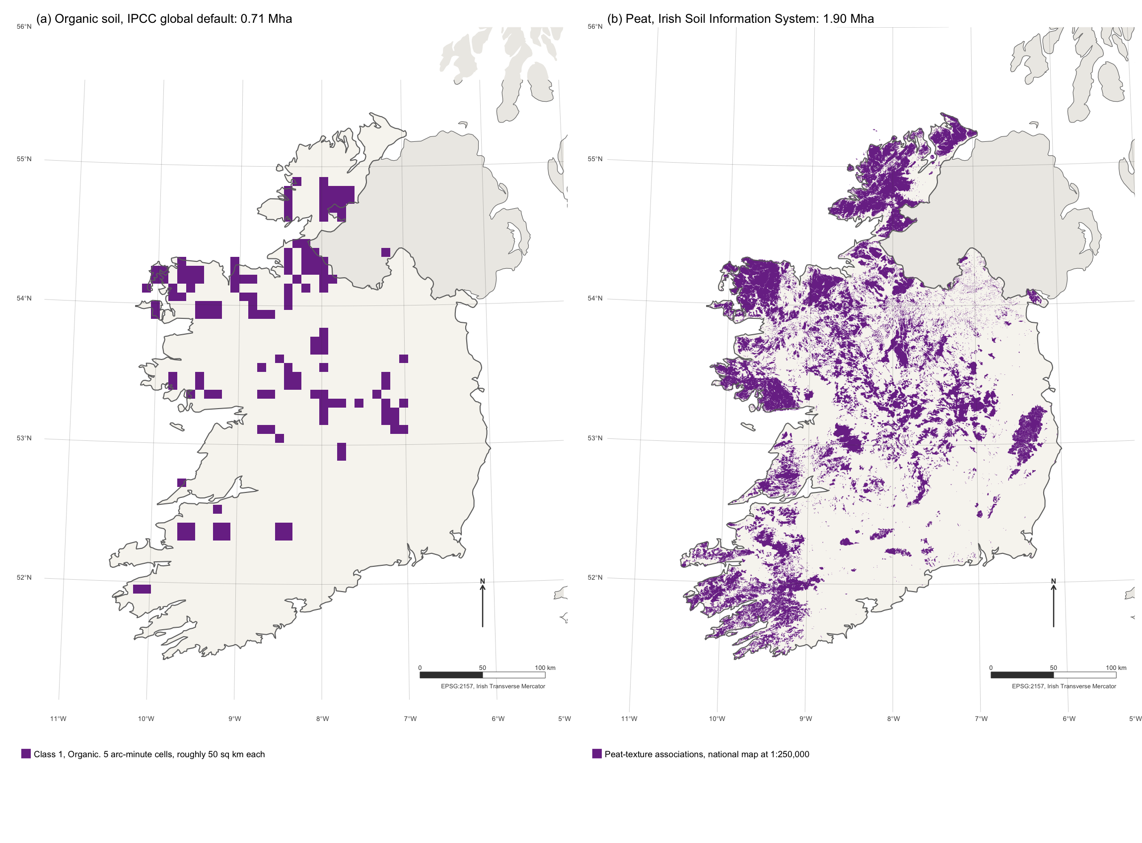
Figure S2. Organic soil as the global default has it, against the national map, at one scale. (a) Cells classified organic in the 5 arc-minute IPCC soil classification, the same layer underlying the estate map and the area weights. (b) Peat-texture associations in the Irish Soil Information System, 1:250,000. Areas are computed from the geometry in EPSG:2157. Graticule at one degree, north arrow and bar scale in the lower right.
Every total in Tables S11 and S12 is a rate multiplied by an area, and it inherits every weakness of both. The rates carry the metric dependence and the sampling uncertainty established in the main text. The areas carry a peatland undercount of unknown size, an unresolvable drained fraction, and for grassland a denominator that is a proxy rather than a measurement. These figures are reported to set scale, not to be cited as estimates of the global carbon flux from these pathways.
Organic soil (Histosols): 131 Mha total; Boreal 104, Temperate 22, Tropical 5.
Wetland mineral (Gleysols): 398 Mha total.
Table S11. Organic soil rewetting, Mt CO2e/yr. Benefit columns are t CO2e/ha/yr averaged over the land uses in each zone. The total columns are an upper bound on the opportunity, not a projection: they assume every mapped hectare is drained and then rewetted.
Zone | Area (Mha) | Benefit GWP-100 | Benefit GWP-20 | Drain-rewet GWP-100 | Drain-rewet GWP-20 | 10% drained, GWP-100
Boreal | 103.9 | 9.99 | 6.25 | 1038.0 | 649.4 | 103.8
Temperate | 22.4 | 12.62 | 1.49 | 282.7 | 33.4 | 28.3
Tropical | 5.0 | 39.03 | 38.78 | 195.2 | 193.9 | 19.5
Upper bound, all organic soil: 1516 Mt CO2e/yr at GWP-100, 877 at GWP-20.
At an illustrative 10% drained: 152 Mt CO2e/yr at GWP-100.

Table S12. The two pathways whose eligible area cannot be derived from soil class. No total at 100% is given: Chapter 5 applies only to cultivated wetland mineral soil being rewetted, and the grassland denominator is ecological zone rather than managed pasture. The columns show what the rate implies at illustrative eligible fractions, which is the most that can honestly be said.
Pool & activity pathway | Area (Mha) | t CO2e ha/yr | Mt CO2e/yr at 5% eligible | Mt CO2e/yr at 10% eligible | Mt CO2e/yr at 25% eligible
Wetland mineral soil, rewetting | 398 | -12.45 | -248 | -496 | -1239
Improved grassland | 1830 | 1.30 | 119 | 238 | 595
Wetland mineral soil: 398 Mha mapped, -12.45 t CO2e/ha/yr, a net SOURCE per hectare.
At 10% cultivated and rewetted that is -495 Mt CO2e/yr.
Grassland proxy: 1830 Mha, 1.30 t CO2/ha/yr; at 10% improved, 238 Mt CO2/yr before any N2O.

Table S13. Irish country-specific factors against the Wetlands Supplement temperate defaults, after Aitova et al. (2023) Table 2. CO2 in t C/ha/yr, CH4 in kg CH4-C/ha/yr. A ratio below 1 means the Irish measurement is lower than the default.
Land use | Nutrient | CO2 Tier 1 | CO2 Irish | Ratio | CH4 Tier 1 | CH4 Irish | Ratio
Grassland | Poor | 5.30 | 1.30 | 0.25 | 1.4 | 8.82 | 6.30
Grassland deep-drained | Rich | 6.10 | 5.08 | 0.83 | 12.0 | -0.75 | -0.06
Industrial cutaway | Poor | 2.80 | 1.21 | 0.43 | 4.6 | 0.00 | 0.00
Industrial cutaway | Rich | 2.80 | 2.18 | 0.78 | 4.6 | -0.30 | -0.07
Domestic cutover | Poor | 2.80 | 1.59 | 0.57 | 4.6 | 4.60 | 1.00
Forestry | Poor | 2.60 | 1.68 | 0.65 | 1.9 | NA | NA
Near-natural | Poor | -0.23 | -0.33 | 1.43 | 92.0 | 54.70 | 0.59
Rewetted extraction | Poor | -0.23 | -0.23 | 1.00 | 92.0 | 79.80 | 0.87
Rewetted grassland | Poor | -0.23 | 0.85 | -3.70 | 92.0 | 68.10 | 0.74
Rewetted extraction | Rich | 0.50 | 3.22 | 6.44 | 216.0 | 117.90 | 0.55
Drained land uses: CO2 ratio 0.25 to 0.83; the lowest is 4.0x below Tier 1.
Same rows, CH4 ratio up to 6.30, i.e. 6.3x ABOVE Tier 1 for Grassland.

Table S14. Confirmed Annex I saltmarsh in Ireland by the salinity regime of the transitional water body containing it. Salinity is water-column, measured at low-tide seine stations in 2015, not marsh porewater.
Salinity class | Area (ha) | % | Polygons
Not surveyed | 1136.8 | 50.1 | 1426
Outside any transitional water body | 893.3 | 39.4 | 3983
Spans 18 ppt | 237.8 | 10.5 | 658
Confirmed Annex I saltmarsh: 2268 ha. Exposed to the sub-18 ppt default: 238 ha (10.5%).
Unclassifiable for want of salinity data: 1137 ha (50.1%).
Methane penalty where the gate bites: 5.23 t CO2e/ha/yr, against a soil gain of 3.34, so the pathway is a net source of 1.89.
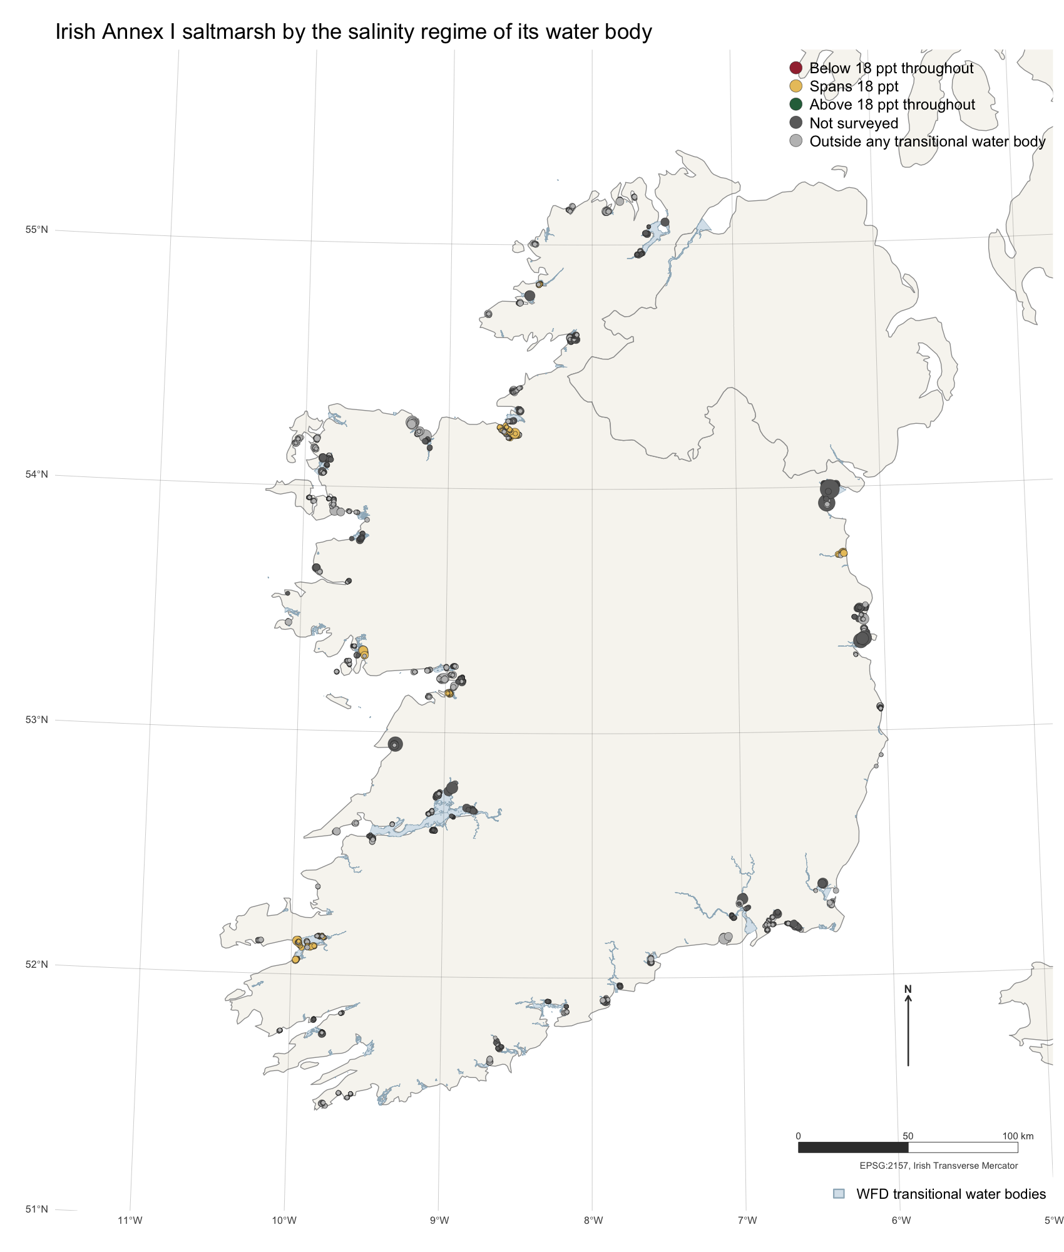
Figure S3. Confirmed Annex I saltmarsh in Ireland, sized by area and coloured by the salinity regime of the transitional water body containing it, over the Water Framework Directive transitional network. No polygon is classified above 18 ppt throughout, and nine tenths cannot be classified at all: dark grey sits in water bodies never surveyed, light grey outside the transitional network entirely.
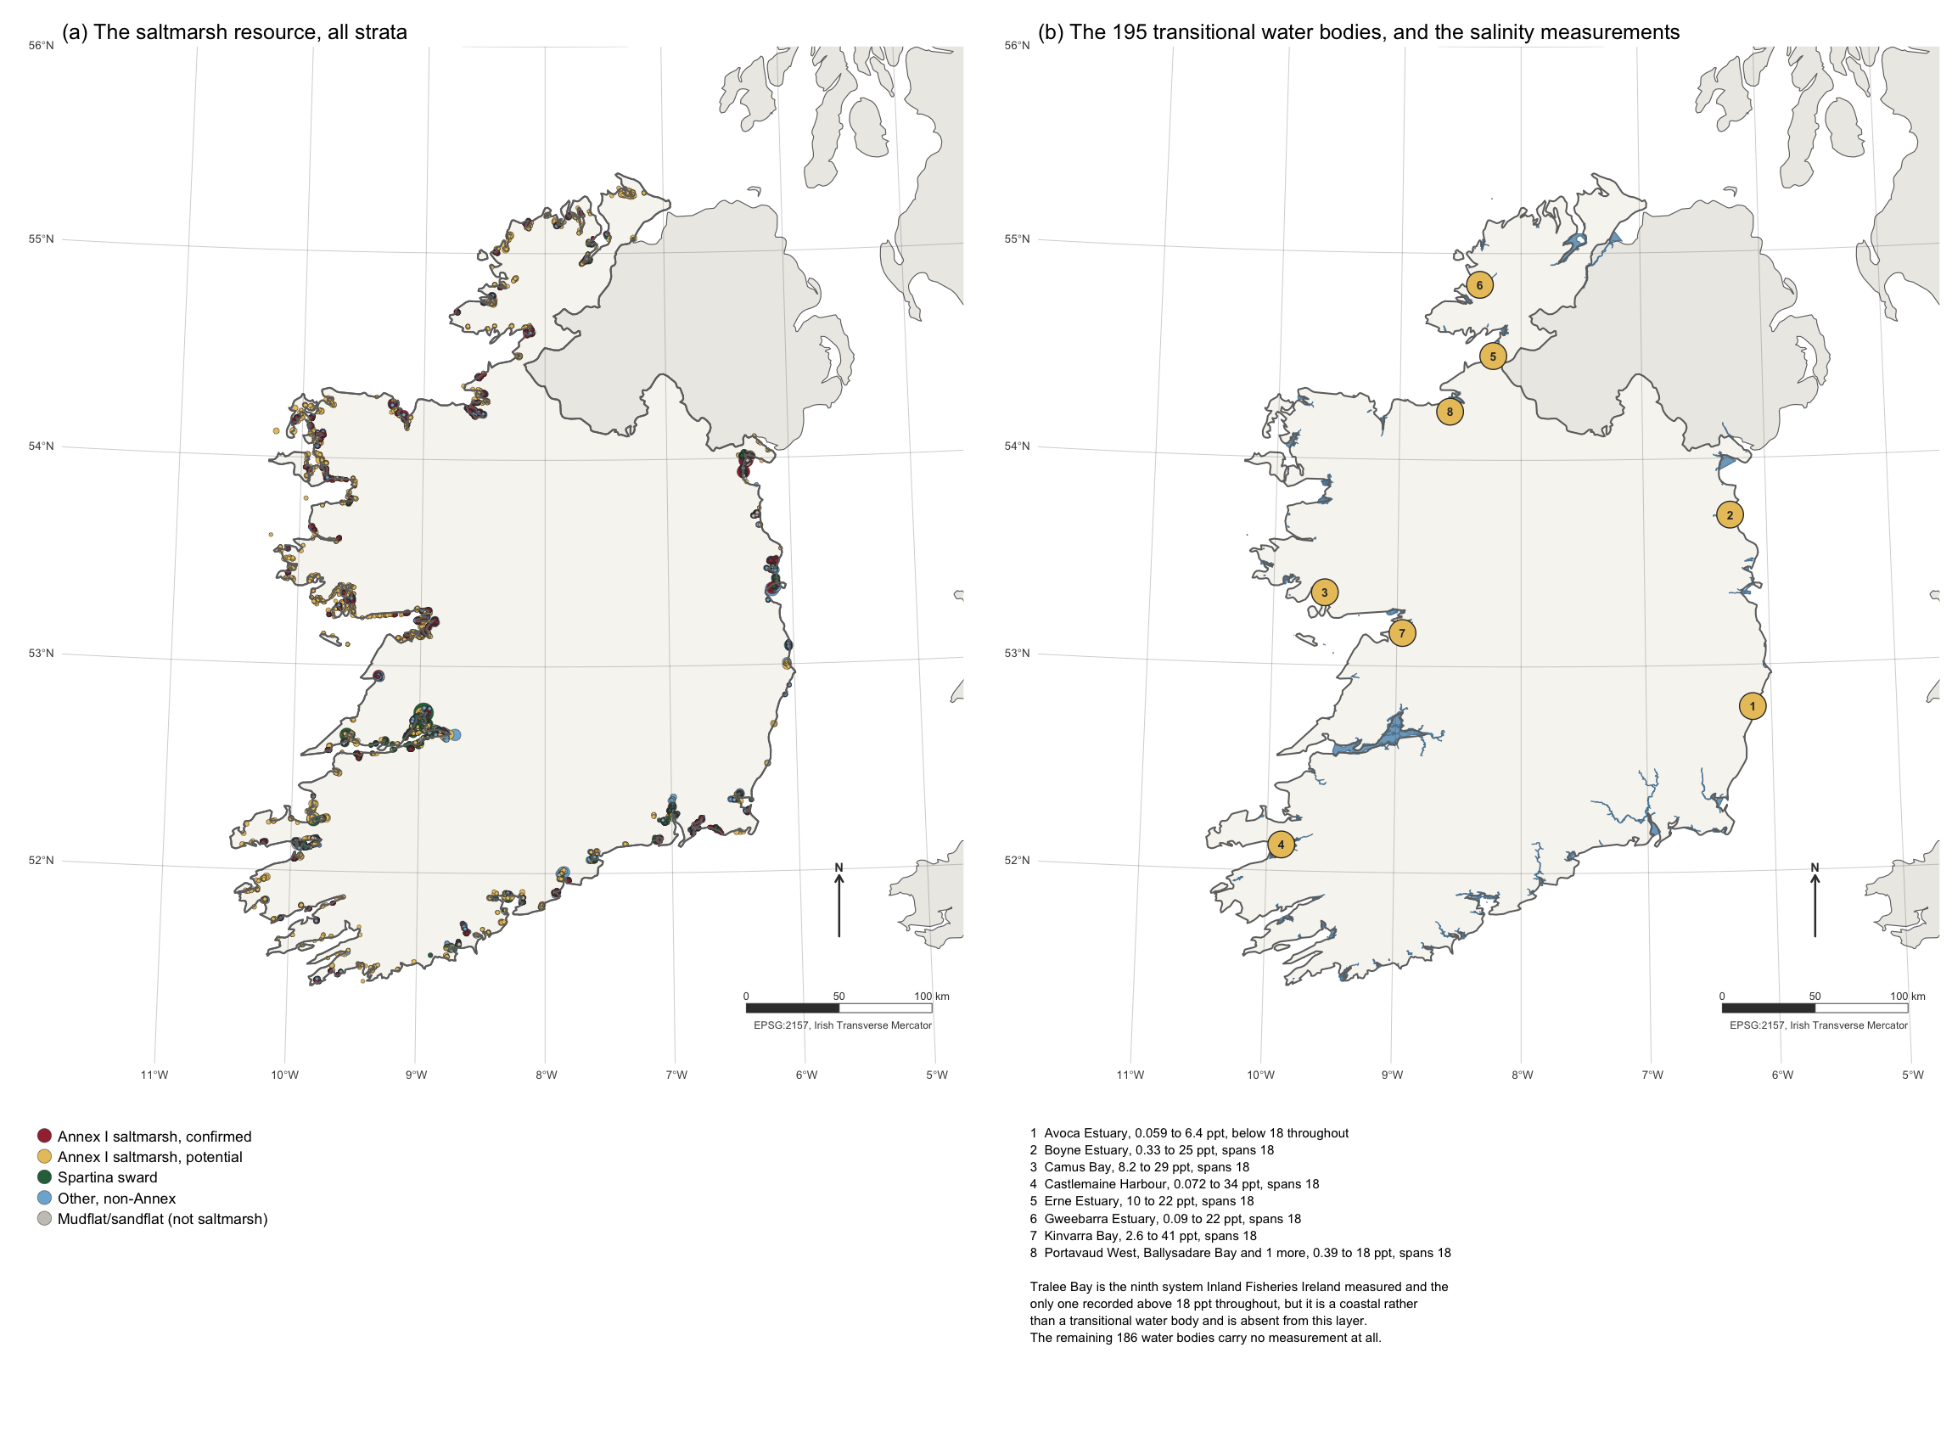
Figure S4. The two Irish coastal datasets behind the salinity gate. (a) The Saltmarsh Monitoring Project resource, all five strata, drawn at polygon centroids and sized by area. (b) The Water Framework Directive transitional water bodies, with the eight Inland Fisheries Ireland systems that carry a 2015 salinity numbered and keyed beneath. Tralee Bay, the ninth and the only one above 18 ppt throughout, is a coastal water body and is not in this layer. Graticule at one degree, EPSG:2157, north arrow and bar scale in the lower right.
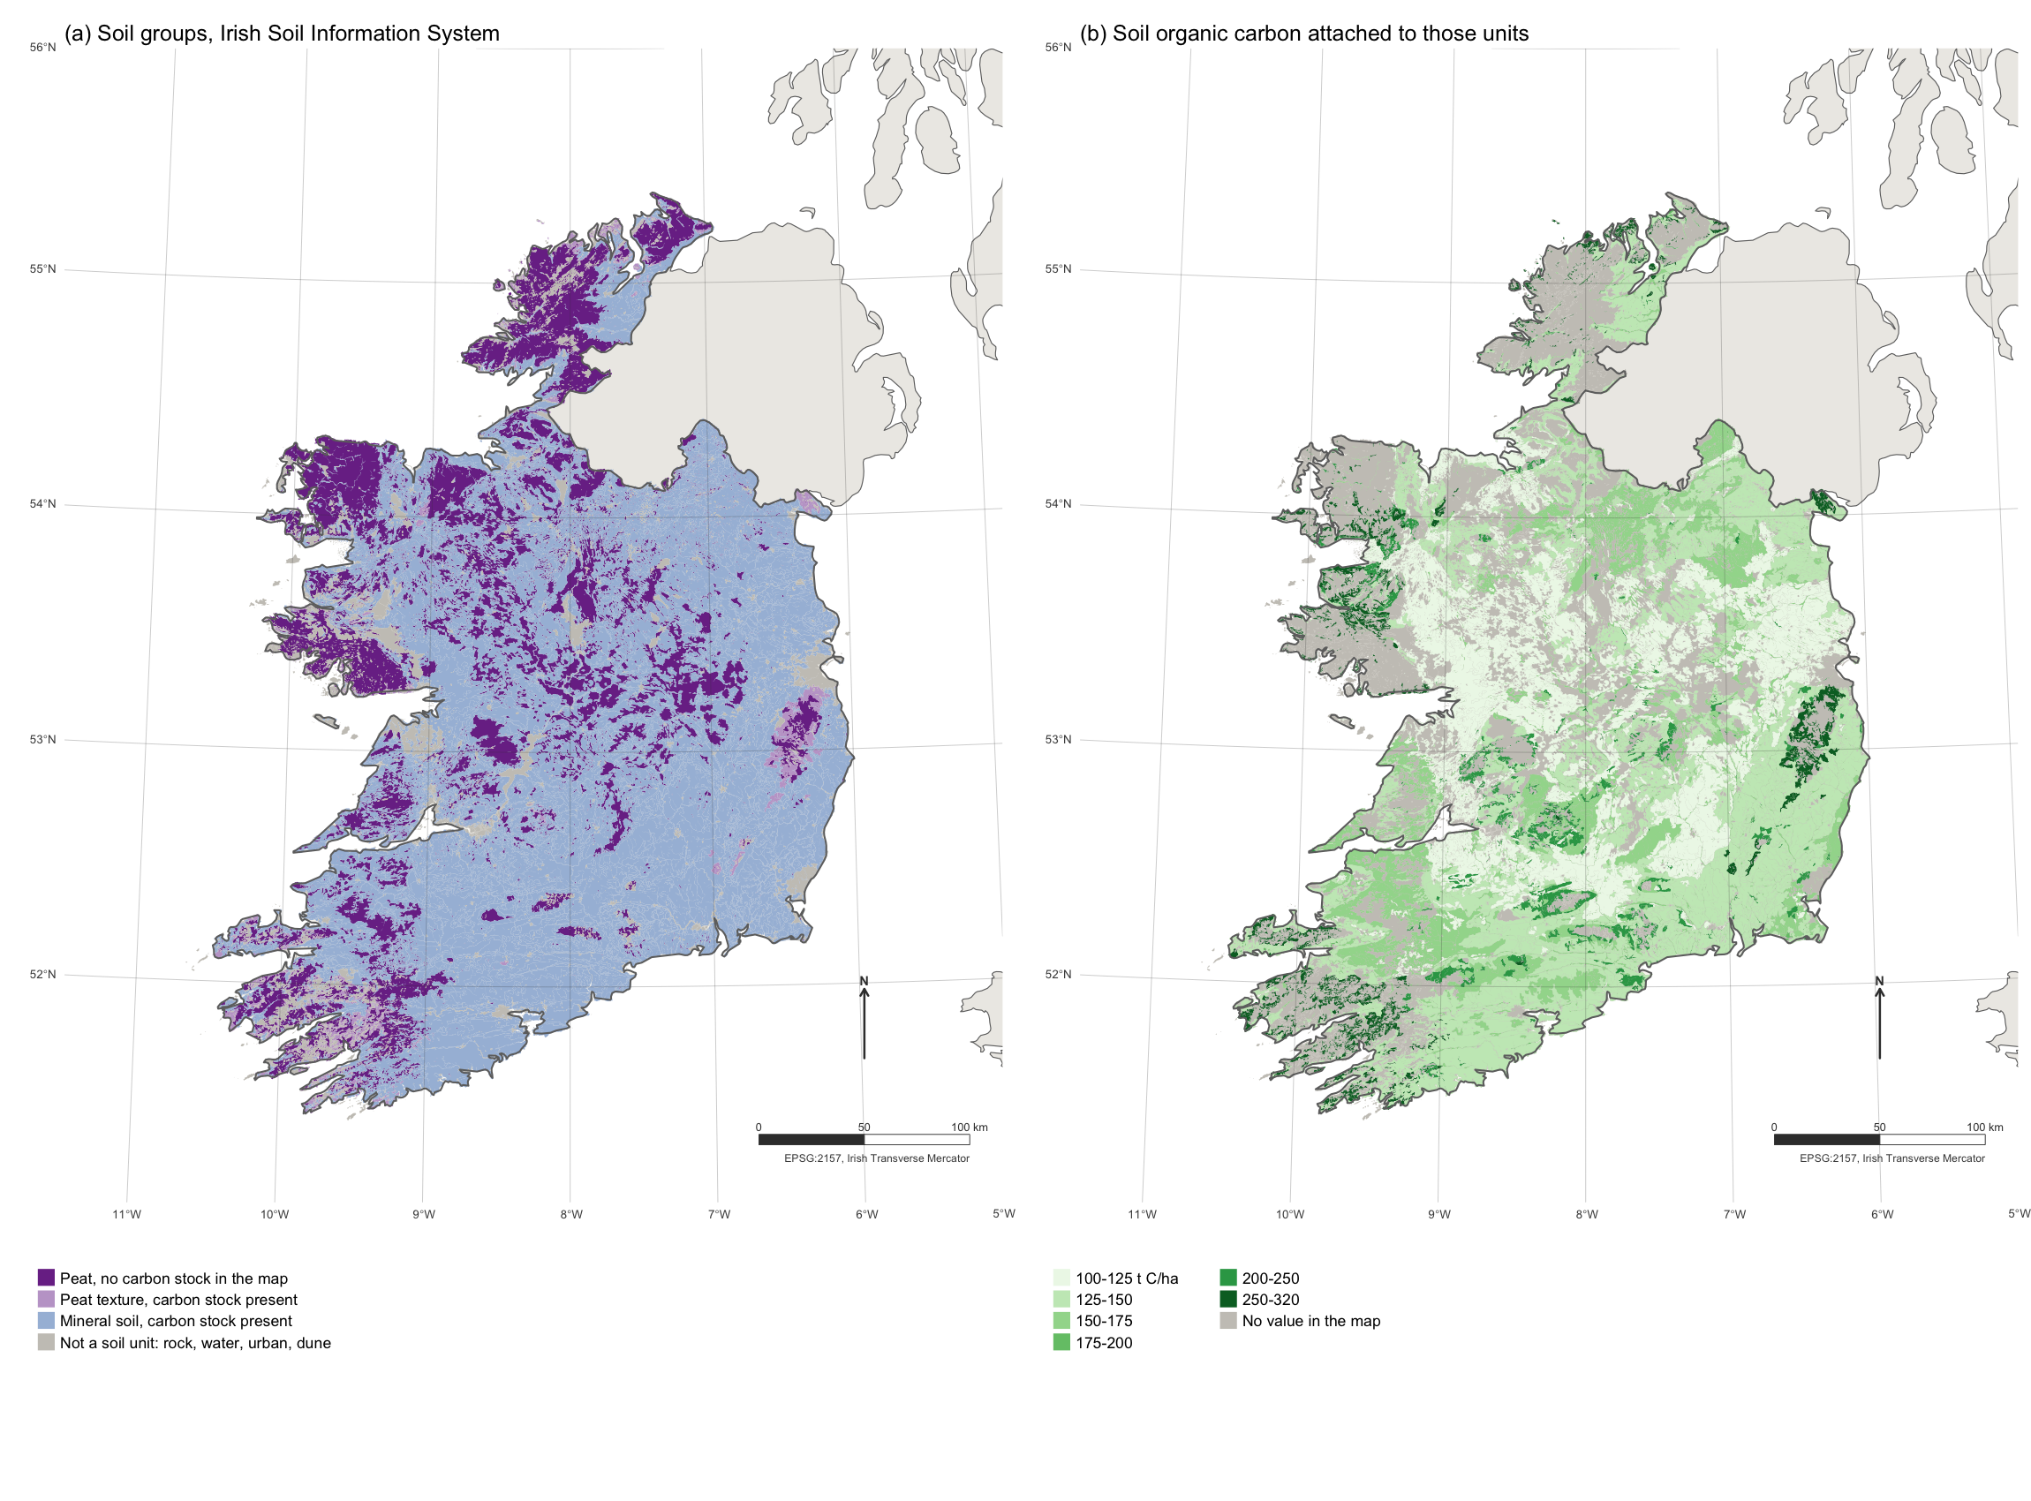
Figure S5. The Irish Soil Information System, 25,143 polygons at 1:250,000. (a) Soil groups, separating peat with no carbon stock in the map from peat that carries one, from mineral soil, from units that are not soils. (b) The soil organic carbon value attached to each unit, with the unattributed area in grey. Northern Ireland lies outside the survey and is shown unfilled. Graticule at one degree, EPSG:2157, north arrow and bar scale in the lower right.

Table S15. Methane from rewetting under three metrics, t CO2e/ha/yr. GWP* charges the step up for two decades and then charges only the residual of a now-constant flux.
Pathway | GWP-100 | GWP-20 | GWP* years 1-20 | GWP* years 21+
Organic soil rewetting | 3.312 | 9.777 | 8.123 | 0.927
Irish industrial peat extraction | 5.689 | 16.793 | 23.175 | 1.593
A sustained flux under GWP* is charged 0.28 times its GWP-100 value once aged past 20 years.
For the Irish case the methane term falls from 5.69 t CO2e/ha/yr at GWP-100 to 1.59 under GWP* beyond year 20, a reduction of 72%.

